Mathew Joseph 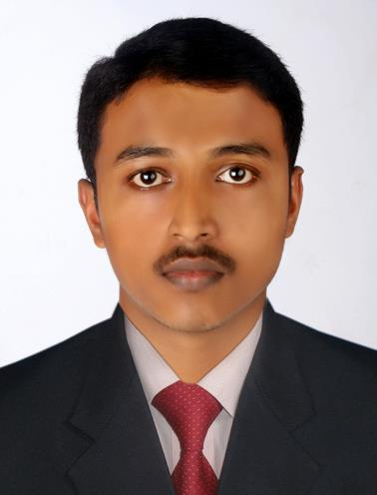
Ayithamattathil (h)
Thampalakadu p. o
Ericadu pin 686506
Kottayam
Email: mathewkanjirapally@gmail.com
Mob: 09567827374

OBJECTIVE
To acquire a demanding position in an environment where I can best develop my skills and education.

EDUCATION
MBA (master of business administration) --- pursuing
University: MS University Tamilnadu.
MTM (Master of Tourism Management) 2011-2013
College : School of Tourism studies.
University : Mahatma Gandhi University, Kottayam, Kerala.
Percentage : 6.71 CGPA

B.Sc. physics (2008-2011)
College : St. Thomas College Palai.
University : Mahatma Gandhi University, Kottayam, Kerala.
Percentage : 63.30%

Higher Secondary (2006-2008)
Board : Board of Higher Secondary Examination, Govt. of Kerala.
Percentage : 71%

Secondary School (2006)
Board : Board of Secondary Education, Govt. of Kerala.
Percentage : 79%.
CAREER RELATED EXPERIENCE
- Eight months work experience in a tour operation company. (Intersight Tours & Travels Cochin ,Kerala)
- Three months work experience as a freelance tour operator (local taxi and houseboat booking only).
- Currently working as an operation executive in Intersight Tours & Travels Cochin, Kerala
WORKSHOPS & OTHER ACHIEVMENTS
- Acted as volunteer in National cross country championship conducted by St. Thomas college Palai.
- Acted as volunteer in international book fair conducted by Mahatma Gandhi university Kottayam.
  - Prepared a documentary about “Destination – Kottayam” for international book fair conducted by Mahatma Gandhi university Kottayam (INBOFA).
PERSONEL DETAILS
Date of Birth : 30-09-1991
Father’s Name : A. M Joseph
Mother’s Name : Celinamma
Sex : Male
Marital Status : Single
Nationality : Indian
Languages Known : English, Malayalam, French (Read only).
INTERESTS
Listening music, Traveling, Photography, Watching T V, Playing cricket and Surfing the web.

DECLARATION
I hereby declare that above furnished information is correct and complete to best of my knowledge and belief.

Mathew Joseph.

